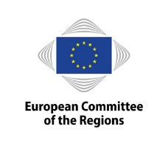
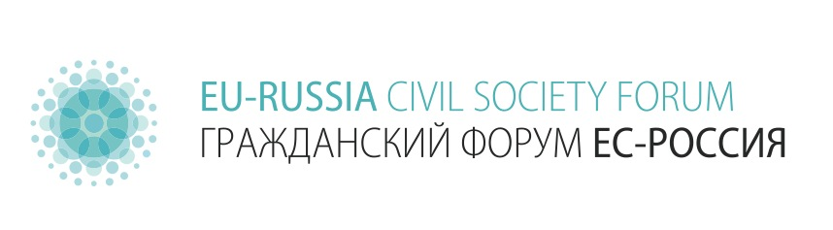


Invitation: "Different Wars" Exhibition Opening in Brussels, 6 September 2017 at 6 pm
Dear Sir, dear Madam,
On behalf of the EU-Russia Civil Society Forum e.V. (Berlin) and Memorial International (Moscow), we are honoured to invite you to the opening of the exhibition
“Different Wars: National School Textbooks on World War II”
that will take place on 6 September 2017 at 6 pm, on the premises of the European Committee of the Regions (Rue Belliard/Belliardstraat 101, 1040 Bruxelles/Brussel, Foyer 5th floor).
Welcome speeches will be held by:
- Karl-Heinz Lambertz, President of the European Committee of the Regions
- Hilde Hardeman, Head of the European Commission's Service for Foreign Policy Instruments
- Arne Lietz, Member of the European Parliament
- Petras Auštrevičius. Member of the European Parliament (tbc)
Speeches will be followed by informal discussions with Nikita Lomakin, Memorial International (Moscow) and Kristina Smolijaninovaitė, EU-Russia Civil Society Forum (Berlin) representing the authors of the exhibition.
The exhibition “Different Wars” reveals the variation in the narration and perception of the history of the Second World War in modern high school textbooks of the Czech Republic, Germany, Italy, Lithuania, Poland and Russia. The choice of the subject was motivated by the fact that WWII remains one of the most painful and conflicting episodes of the European nations’ memories. The modern high school textbooks were chosen as they communicate the spirit of their time and express the culture they are written in.

The exhibition was prepared, among others, by Karta Centre (Warsaw), Antikomplex, z.s. (Prague), EU-Russia Civil Society Forum e.V. (Berlin) and the Memorial International, (Moscow), which was given the Sakharov Prize by the European Parliament in 2009.

The exhibition enjoyed already a great success in the European Parliament (Strasbourg), the Czech Republic (Prague), Germany (Muenster), Italy (Milano), Lithuania (Vilnius), Poland (Wojnowice) and Russia (Krasnoyarsk, Moscow, Novosibirsk, Perm, St. Petersburg, Syktyvkar, Yekaterinburg).
We kindly ask you to confirm your attendance until Sunday, 3 September 2017, by sending a short message to events@eu-russia-csf.org with your full name, ID/Passport number and organisation (if applicable). This information will be needed while entering the building.
We look forward to welcoming you at the opening ceremony and would be grateful for sharing this invitation with whoever might be interested.

Yours sincerely,
Kristina Smolijaninovaitė
Curator, EU-Russia Civil Society Forum
www.eu-russia-csf.org
kristina.smolija@eu-russia-csf.org

****
The exhibition was initiated by the Working Group “Historical Memory and Education” of the EU-Russia Civil Society Forum in close cooperation with historians, civil society activists, history teachers, and enthusiasts from all the countries involved.
To learn more on the exhibition, please follow the link: http://eu-russia-csf.org/home/projects/different-wars/

The EU-Russia Civil Society Forum was established in 2011 by non-governmental organisations as a permanent common platform. At the moment, 156 NGOs from Russia and the European Union are members of the Forum. It aims at development of cooperation of civil society organisations from Russia and EU and greater participation of NGOs in the EU-Russia dialogue. The Forum has been actively involved, inter alia, in the questions of facilitation of visa regime, development of civic participation, protection of the environment and human rights, dealing with history, and civic education. The Secretariat is based at DRA / German-Russian Exchange (Berlin, Germany).

Supported by: In cooperation with:

